PRACTICAL-6

1. Download **xampp** and install it. After installing xampp, open the xampp control panel and start two services : Apache and Mysql.
2. Download **DVWA(DAMN VULNERABLE WEB APP)** from its official site.
3. Extract the folder and rename it to "dvwa".
4. Copy that folder into C:xampp:htdocs: paste here.
5. Now open dvwa folder then open config folder under that make a copy of config.inc.php.dist
6. Then rename it to config.inc.php

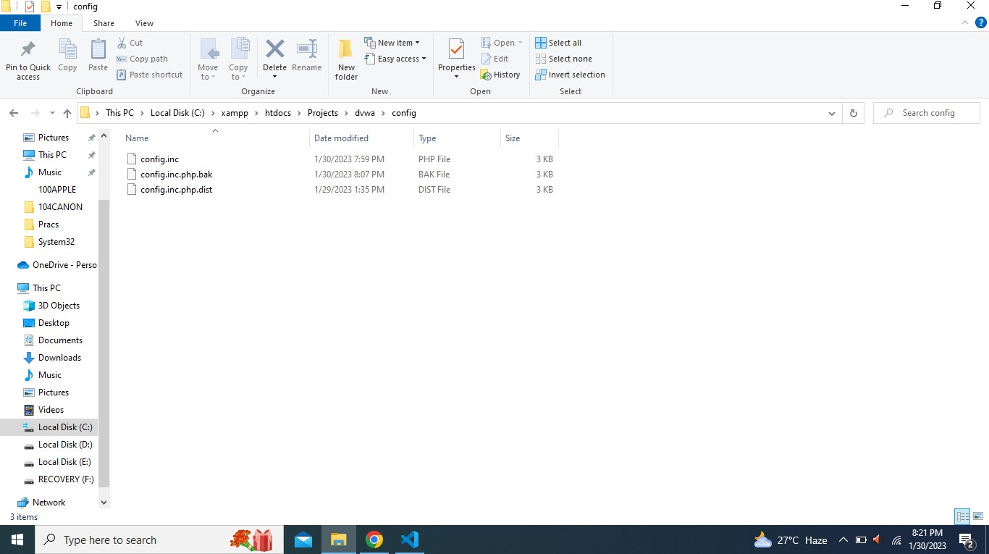

1. Open it with any text editor and remove the password and change database and user to root.

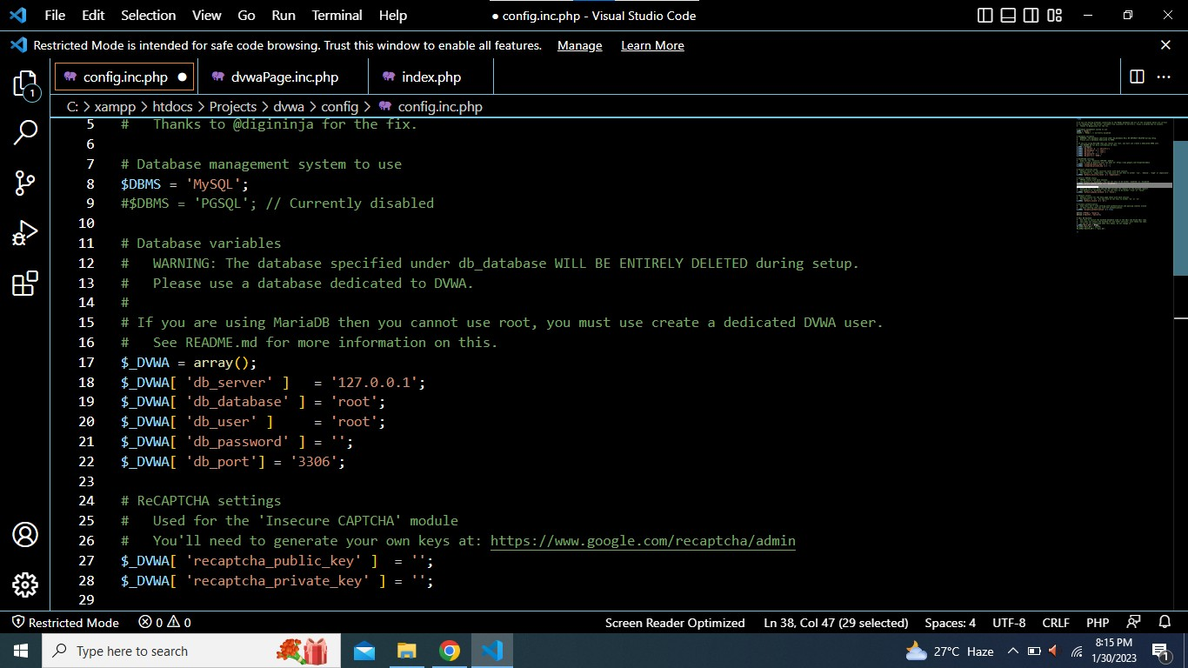

1. Now go to the localhost/dvwa/ Then in the bottom click create database button.

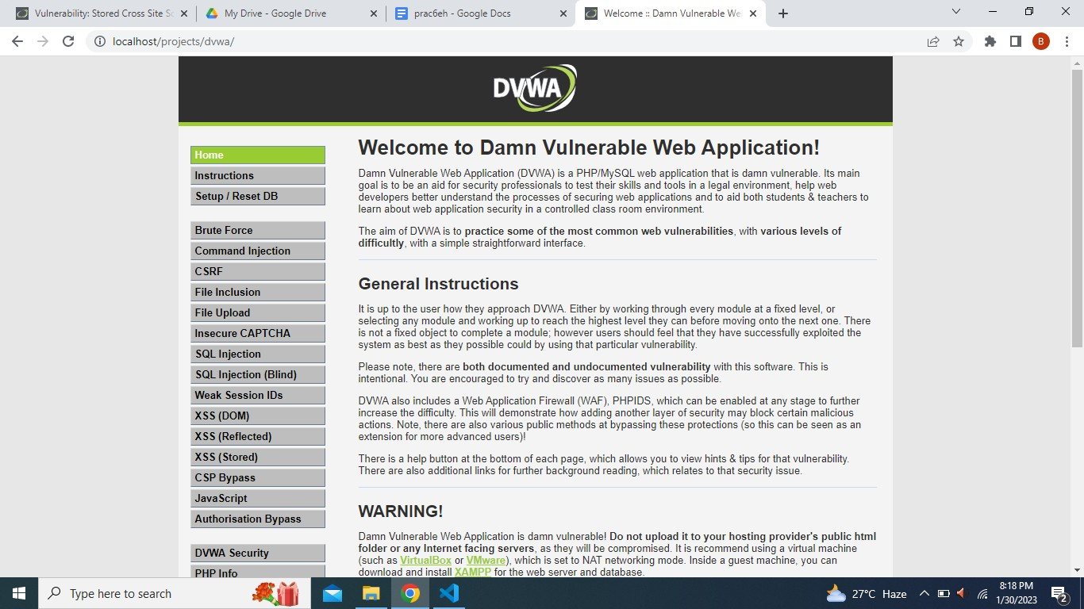

1. Wait a second you will be redirected to the login page.
2. Now enter the login ID and password as admin/password.

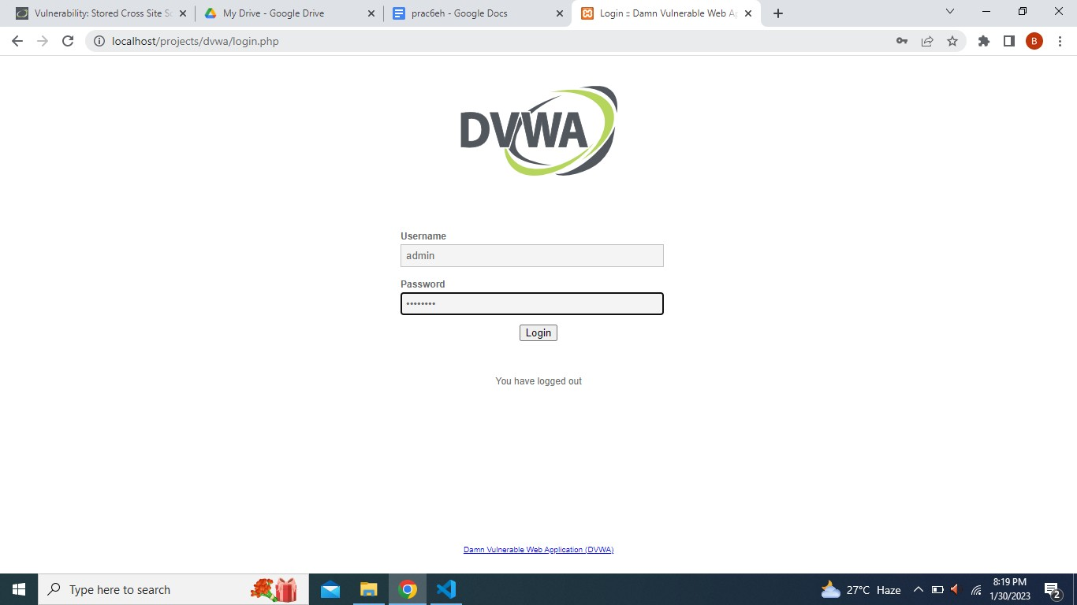

1. After successful login click the fourth last option and set the security level to low and click on submit.

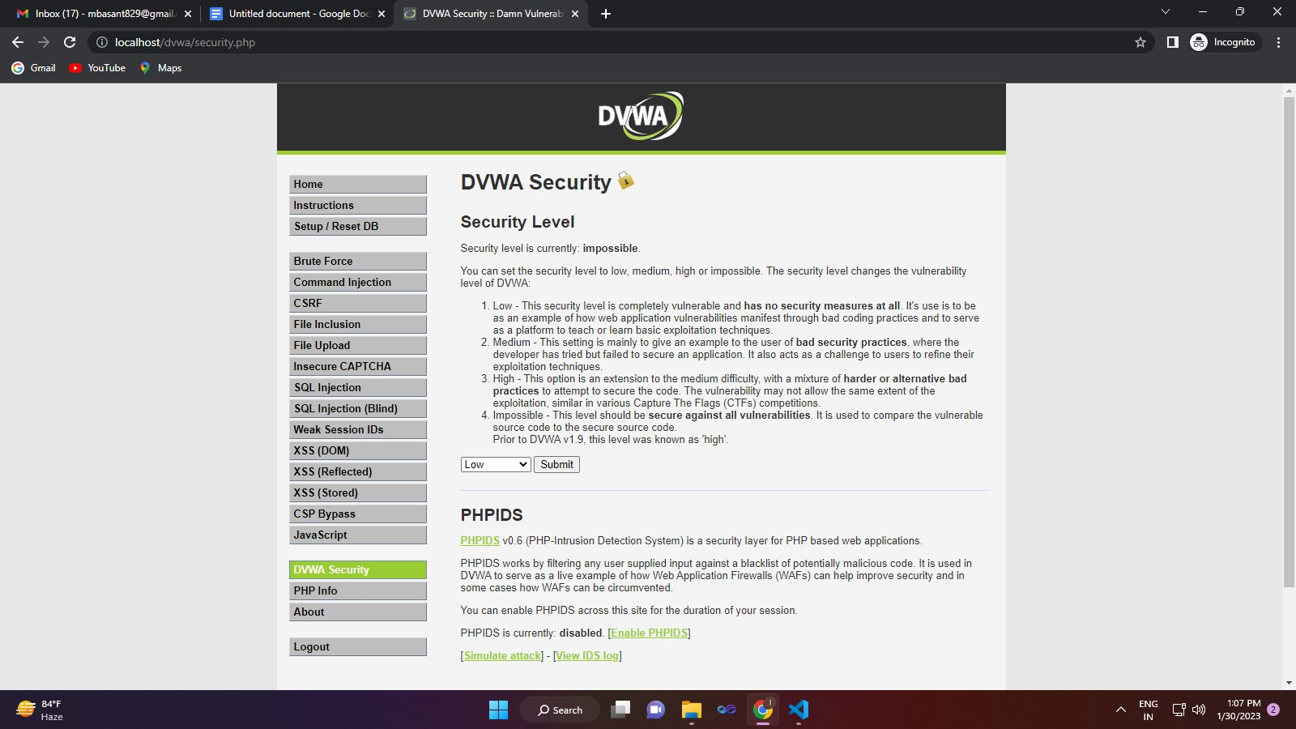

1. Then click on XSS(stored) and type any name and type the script that you want to inject.

